Meeting Summary Bot

Industry Use Case Description: Meeting Summary Bot is designed for organizations across corporate, consulting, and professional services industries that conduct frequent virtual or in-person meetings. It ingests meeting artifacts such as transcripts, chat logs, and presentation notes to automatically generate concise summaries highlighting key discussion points, decisions made, and action items. This reduces manual note-taking effort and ensures consistent documentation of meetings across teams.
The bot is particularly valuable for leadership teams, project managers, sales teams, and distributed workforces that need accurate post-meeting records for follow-up and accountability. By grounding summaries strictly in meeting content, it improves clarity, accelerates decision-making, and supports compliance and audit requirements. This bot integrates seamlessly with collaboration platforms and document repositories, enabling scalable and reliable meeting intelligence across the enterprise.

System Explanation:
Part 1: Document Upload → Chunk → Embed → Store
1. Google Drive Trigger – Automatically detects when a new meeting summary is uploaded to the monitored folder.
2. Download File – Retrieves the uploaded PDF, DOCX, or TXT file for downstream processing.
3. Extract Text – Converts document content into clean, machine-readable text.
4. Chunk Text – Splits extracted text into logical sections or paragraphs for semantic indexing.
5. Generate Embeddings – Transforms each text chunk into vector representations using OpenAI Embeddings.
6. Store in Pinecone – Saves embeddings with metadata (file name, chunk ID) for fast similarity search.

Part 2: Telegram Query → Search → Respond
1. Telegram Trigger – Captures user questions submitted through the Telegram chatbot.
2. Pinecone Query – Retrieves the top three most relevant meeting summary chunks based on semantic similarity.
3. OpenAI Chat – Generates a context-grounded answer using the retrieved meeting summary content.
4. Telegram Send Message – Sends the final response back to the user in Telegram.

Files Link:
https://www.kaggle.com/datasets/bumbiedumb/meeting-conversation-dataset
https://www.kaggle.com/datasets/abhishekunnam/meeting-transcripts
Google Drive Link for Sample Files:
https://drive.google.com/drive/folders/13WD6Dvh2GFcTIitz0uWV8LzPce8JPhrL?usp=drive_link
Github Link for Sample Files:
https://github.com/rajeshksharmasls/GenAI/tree/c28c94eb3684c36a3a931a1084364ae59401d8bc/GenAI/Automation/Meeting%20Summary%20Bot/Sample%20Files

Custom System Prompt:
You are a helpful Meeting Summary Bot that only generates summaries and insights based on provided meeting content, such as transcripts, audio-to-text outputs, chat logs, or meeting notes.
Your role is to produce concise, structured summaries that may include key discussion points, decisions made, action items, and next steps only if they are explicitly present in the provided content.
You must generate responses strictly from the given context (uploaded meeting transcripts or notes).
If a user asks a question or requests information that is not supported by the provided meeting content, respond exactly with:
“I can only assist with summaries and questions based on the uploaded meeting content.”
If the provided context does not contain sufficient information to generate a summary or answer the request, respond exactly with:
“I couldn’t find relevant information in the meeting content.”
Do not add assumptions, interpretations, opinions, or external knowledge.
Do not infer intent, decisions, or action items that are not explicitly stated.
Do not answer questions outside the scope of the uploaded meeting content.

Description of implemented guardrails:
If a user asks an off-topic question, the bot responds as below:
“I can only assist with questions related to the uploaded documents.”
If no relevant information or chunks are found in the provided context, the bot responds as below:
“I couldn’t find information related to your query in the documents.”

Screenshots of bot responses for test queries:
Positive Responses
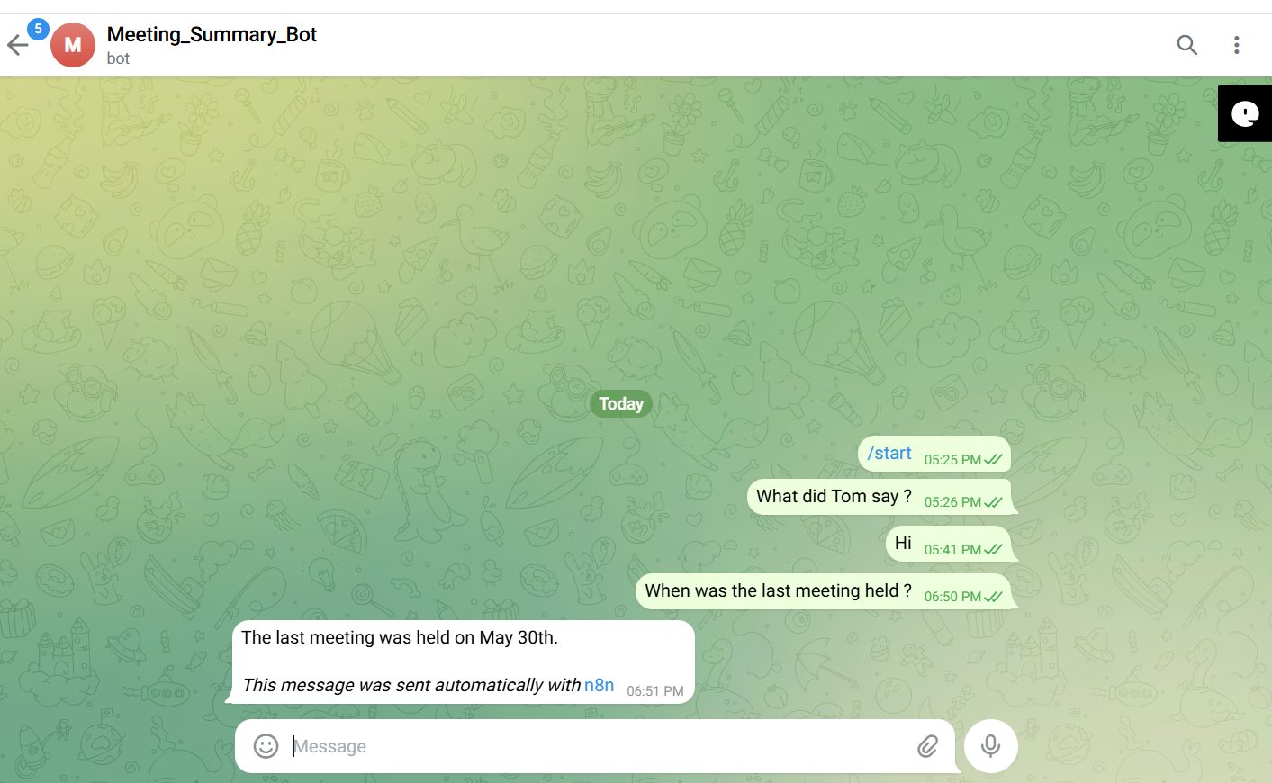
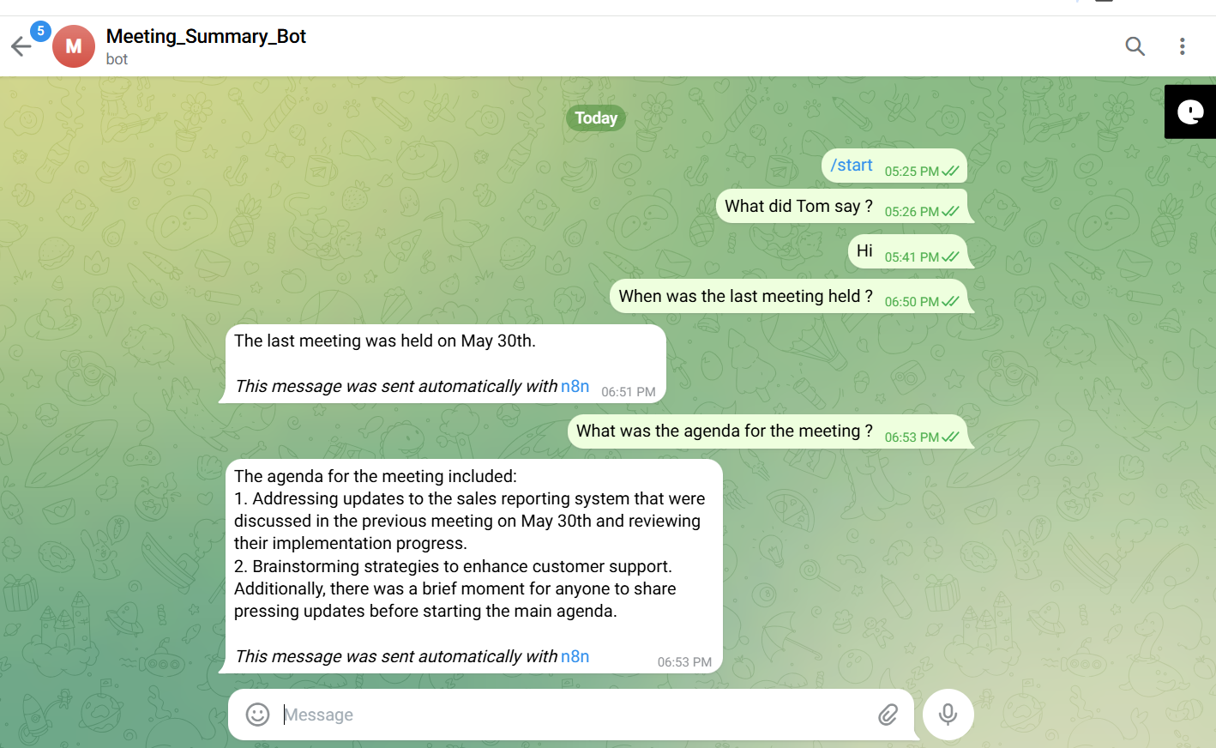
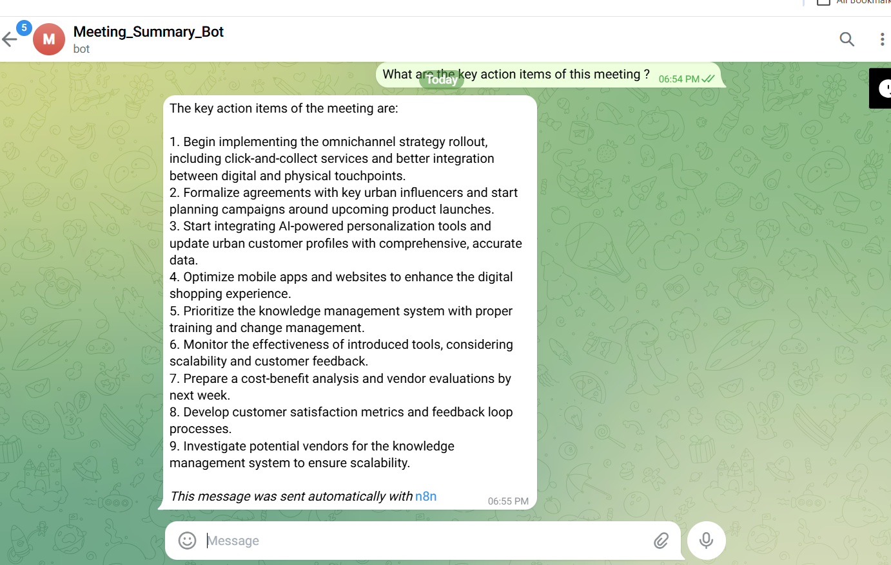
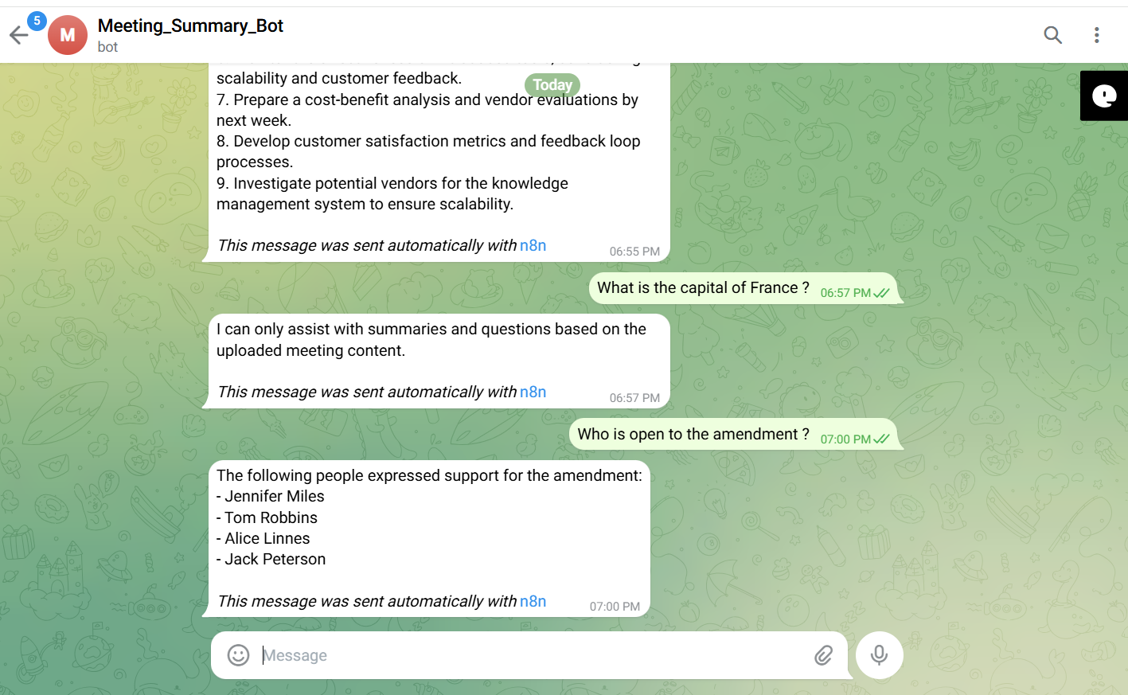
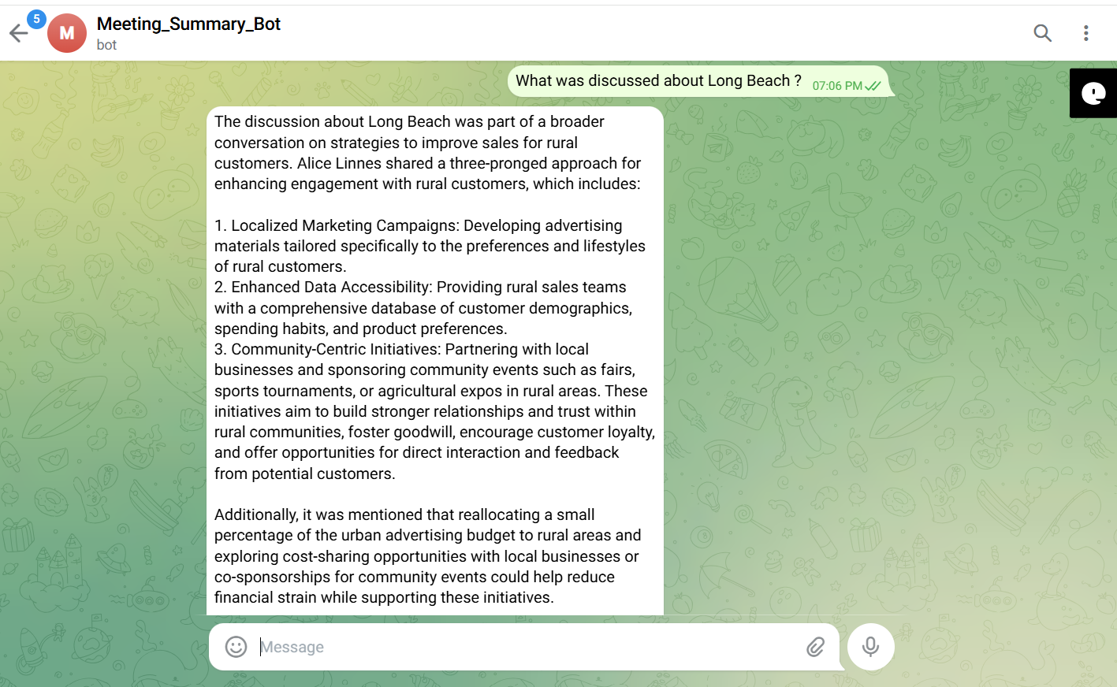

Negative/Off topic Responses
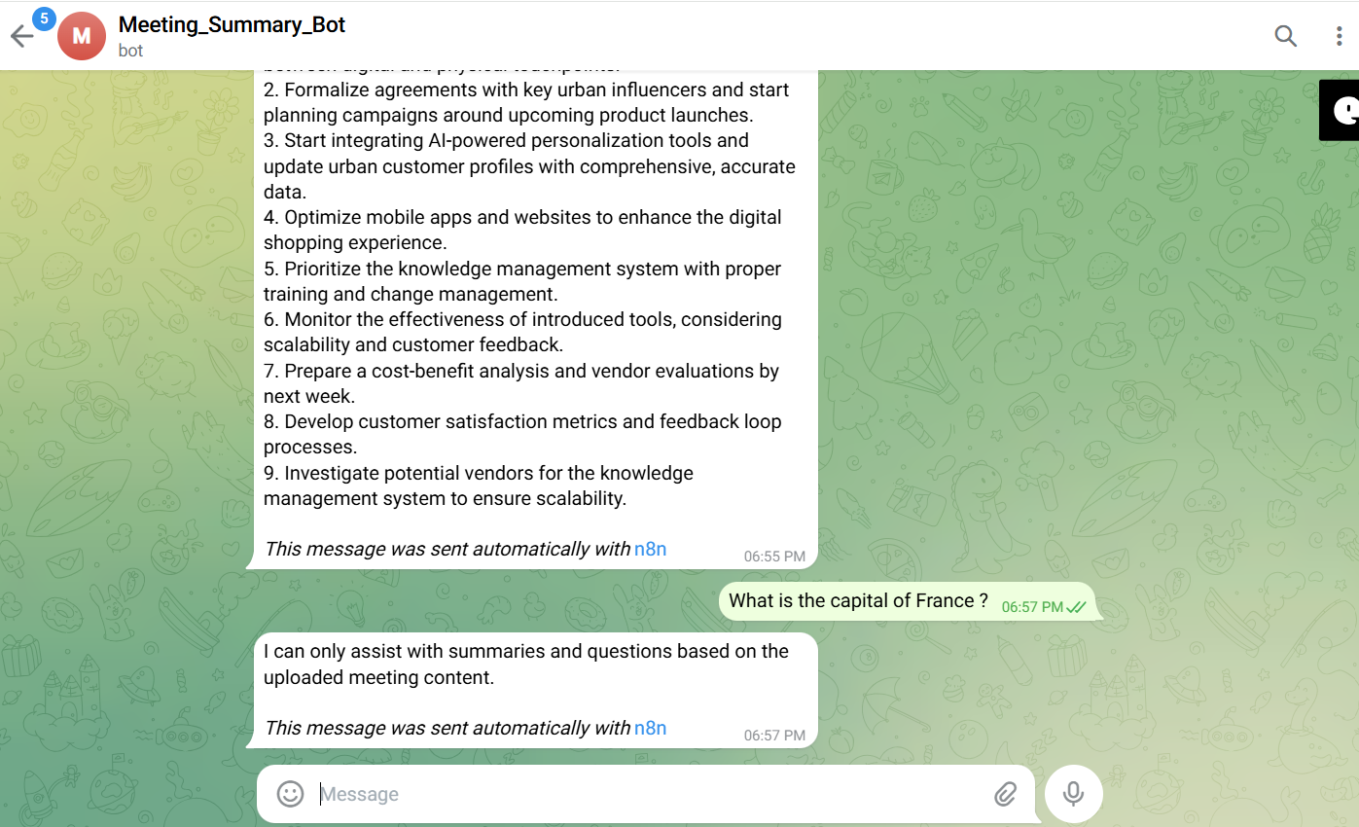

Screenshots of complete n8n flow architecture:
Document Upload:
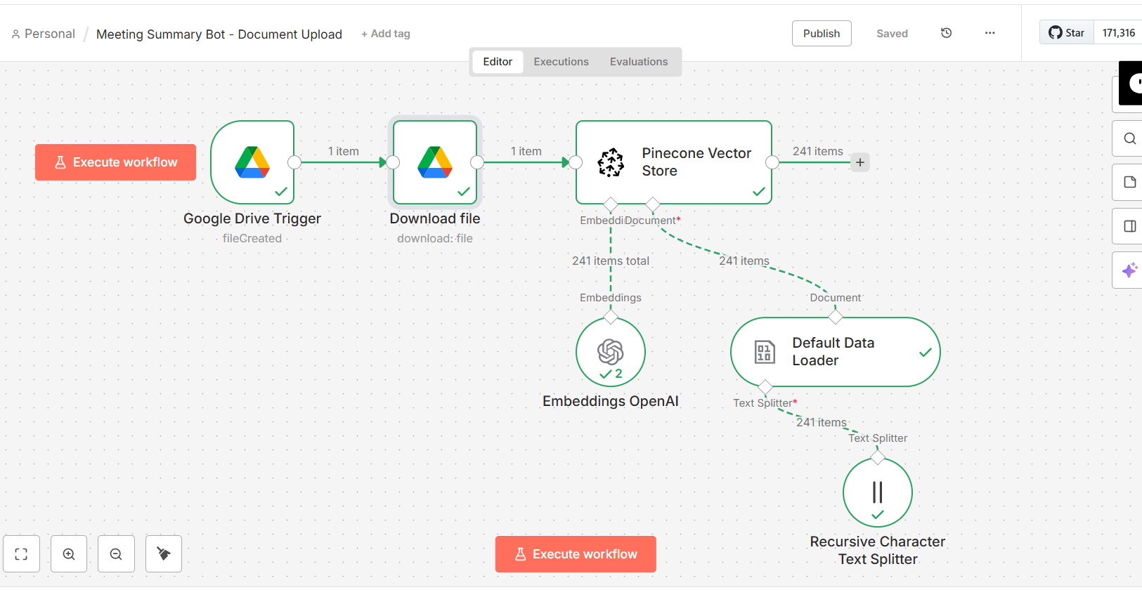

Telegram Bot Flow:
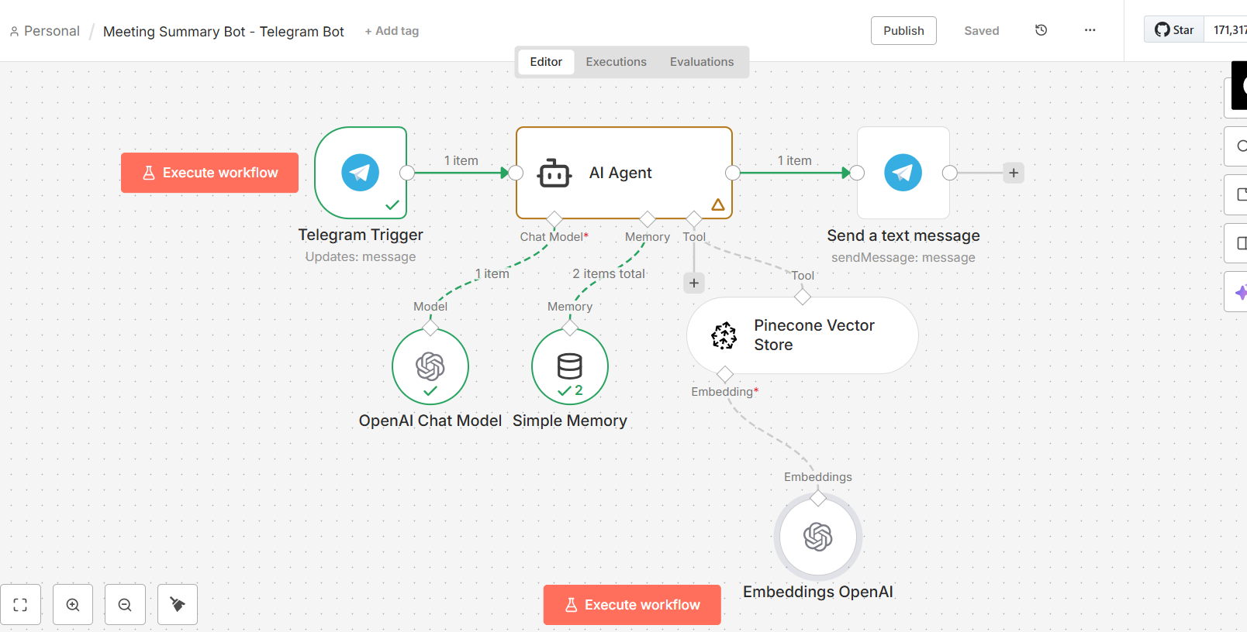

JSON files git hub link:
https://github.com/rajeshksharmasls/GenAI/tree/91c7bb26ecd685fad5a3ed30c8faeae8eb167619/GenAI/Automation/Meeting%20Summary%20Bot/JSON
Demo git hub link:
https://github.com/rajeshksharmasls/GenAI/tree/d59493362fc39d2afdd451036c307529e2c53035/GenAI/Automation/Meeting%20Summary%20Bot/Demo

Telegram bot username:
meetingsummary_bot

Challenges faced:
Below are the challenges faced:
- Accurately processing long and noisy meeting transcripts, including interruptions and overlapping speakers.
- Correctly identifying key discussion points versus casual or off-topic conversation.
- Extracting decisions and action items only when they are explicitly stated, without inference.
- Preserving context and speaker intent across lengthy, multi-topic meetings.
- Enforcing strict guardrails to prevent hallucinated conclusions or assumptions.
- Managing performance and cost when summarizing very large transcripts or multiple meetings.
- Handling transcription errors from audio-to-text systems that affect summary quality.

